Harding Lake Water Level Stabilization Project

Summary and Recommendation

3/11/04

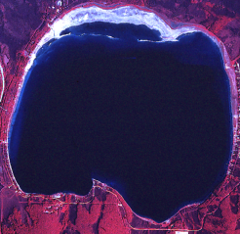
UAF Photo
Executive Summary

This document describes some of the history and problems associated with the low water level of Harding Lake, a solution that has been funded by Congress, and a recommendation for a stable water level.

The lake has gone through periods when the lakebed has been covered and water is to the banks, and periods of low water exposing hundreds of acres of lakebed. The lake is currently low; 5 feet lower (vertically) than it was in 1968 and at least 5 feet lower than it has been at other times in the last 60 years. This has created large areas of gravel flats (colonized by terrestrial grasses and shrubs, essentially turning into woodlands if left untouched) or silty, boggy flats in front of what once was lakefront property. Areas of dense aquatic vegetation once prevalent primarily in the northern flats of the lake have begun to colonize areas in front of the developed areas. Public and private boat launches have become unusable. Harding Lake was the only viable roadside northern pike fishery in Interior Alaska that produced large fish. Almost all of the high quality spawning and rearing area for northern pike dried up, causing a drastic decline in the northern pike population. The Alaska Department of Fish and Game (ADF&G) and the State Board of Fisheries have been forced to close fishing for northern pike until such time as habitat restoration allows recovery of the pike population.

When the lake level dropped for the first time in the current sequence of declines and rises, in the 1970’s, the Alaska Department of Natural Resources commissioned an elevation survey, done by a private contractor, and a hydrological study, done by the Institute of Water Resources at the University of Alaska. These studies are part of the foundation of the Congressionally funded solution.

A stream (Rogge Creek) flowing from a basin to the east of Harding Lake, which has historically either flowed into the lake or the Salcha River, can be stabilized so that part of its water flows into the lake at a controllable rate, allowing the lake to be maintained at a higher and stable level. Surveys, inspection of aerial photographs, and on-site inspections have identified an outlet channel from the lake in the northern woodlands that will carry water to the Salcha River if the water level is more than about 3.5 feet above the current level and the berms on the north end of the lake are open.

The Harding Lake Association and the Harding Lake Watershed Council, in a process facilitated by the Delta Soil and Water Conservation District (SWC), developed information and a strategy to control Rogge Creek, and Congress provided funding for the project. SWC brought National Resource Conservation Service (NRCS) into the process. NRCS has agreed to provide engineering and to oversee construction of the project. Sport Fish Division of ADF&G has agreed to maintain and operate the project provided that it achieves objectives designed to benefit northern pike. After reviewing research literature evaluating similar restoration projects and northern pike spawning habitat requirements, ADF&G has recommended that the lake be maintained at a level approximately 3 feet above the level of 2003 (within its lakebed, about where it was in 1990 and about 2 feet lower than in 1968). This will adequately restore the northern pike spawning and rearing habitat, benefit other fish and wildlife, and provide benefits to the majority of users of Harding Lake. Operation of the diversion structure will control flooding and allow diversion of the stream away from the lake if melting ice lenses or other factors cause heavy siltation.

Harding Lake Water Level Stabilization Project

Situation Description and Project Recommendation

Compiled by M. Doxey-
Updated 3/11/04

General Description

Harding Lake, located 44 miles southeast of Fairbanks along the Richardson Highway, has a surface area of about 2,500 acres when the lake level is high enough to submerge the entire lakebed. Maximum depth is about 140 feet. About 60% - 70% of the lakeshore is bordered by private property. There is also a State Campground and some wildlands. Harding Lake is the largest roadside lake north of the Alaska Range, and important to residents and visitors for boating, fishing, swimming, and other water recreation, and winter recreation.

There is no documented outlet down which water has been seen flowing. Water loss from the lake has traditionally been attributed to evaporation (and some subsurface flow). However, survey work along the north end of the lake indicates that water will flow from the lake to a channel that leads to the Salcha River floodplain if the lake level is high. Lake water level has historically fluctuated from high - up on the banks - to low, with hundreds of acres of exposed lakebed in some areas.

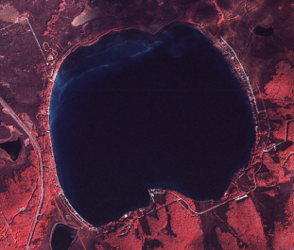
Water levels have fluctuated 3 to 5 feet. Within the lifetime of many of the people associated with Harding Lake, the lake has been full with the lakebed almost completely underwater at least twice (photo at left), and (including the present event) has fallen to a low level at least twice. Older people remember more of these cycles. The lake was also quite low in the 1940's. The most recent series of changes began after the 1967 flood (Doxey, 1991). In 1968 the surface elevation of the lake was at about 720.3 feet ASL (Above Sea Level; this and all other
UAF Photo

elevations corrected to NAVD 1988), and had likely already declined from the higher level immediately after the 1967 flood. By 1978, the survey of the lake commissioned by the Alaska Department of Natural Resources, Division of Land and Water Management determined that the surface elevation of the lake was 715 feet ASL (Boutet, 1978). Thereafter it recovered four feet to about 719 feet ASL in 1985 (based on photographic evidence), before starting to drop again. It is presently at about 715 feet ASL.

Problems arise when the lake level fluctuates. This document describes the present status of the (low) lake level, the implications, and what might be done to stabilize the lake level.

Fisheries Impacts of Low Water Level

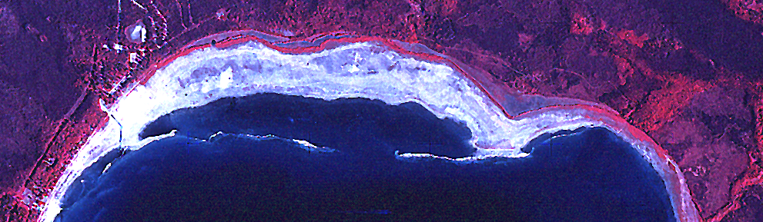
When the lakebed is covered with water, there are about 223 acres of swampy wetlands at the north end and in narrow zones along the margins of the lake. Eighty percent of this acreage is between the north end of the beachline of the State Campground and the north end of the private property along the eastern shoreline. When the lake is low, as it is presently (late 1990’s - 2003) and was in the late 1970's, virtually all of the productive wetlands dry up (below). As the lake
UAF Photo

drops the dessicated areas are colonized by terrestrial grasses and deciduous vegetation (willows and birches).

The area of emergent vegetation is crucial to the population of northern pike, least ciscos (the small whitefish that provide most of the forage base for the large predators of the lake - northern pike, burbot, lake trout, and Arctic char), waterfowl, and muskrats, and any other animals that require or take advantage of this type of habitat. It is the preferred spawning habitat for the pike. In springtime, as soon as the ice lifts a little along the margins of the swamps, which by then are thawing and warming up, pike move into the shallow vegetated areas to spawn. By the time the ice is gone the spawning is completed. The warmer water of the swampy areas causes the eggs to develop rapidly, and after hatching the young pike take advantage of warmth, abundant food (primarily insects, but also each other and other fish that might stray in) and dense cover to grow rapidly until cool fall weather forces them to the margins of the open water.

When the lake level drops, spawning and rearing areas dry up or become unusable, and the young pike that do initially survive are forced to the thin zones of emergent vegetation remaining and the margins of the open water, where survival declines. The young pike have little cover and are subject to increased predation by other pike and fish-eating birds. They are subjected to wave action, which probably forces them out to deeper, colder water. Stock assessment conducted by ADF&G Sport Fish Division during 1999 showed a sudden recruitment failure (no young fish) within the pike population (Scanlon and Roach, 2000). The missing age classes correspond with water level declines that would have dried out spawning habitat. It is important to recognize that sport fishing did not drive the pike population into the ground. The parent stocks of the missing age classes were sufficiently abundant, and good recruitment should have resulted (Roach, 1998). This is the second time in 30 years that the spawning and rearing areas have dried up and the cumulative impact has decimated the pike population.

In May, 2000, northern pike fishing at Harding Lake was closed indefinitely by emergency order. In January, 2001, the State Board of Fisheries, at the recommendation of ADF&G, closed the northern pike fishery by regulation. The Department will return to the Board of Fisheries with a proposal to open pike fishing to catch-and-release and subsequently to some level of harvest when the pike population recovers to a point that those fisheries can be sustained. A fisheries management plan has been written by ADF&G outlining the recovery steps. Recovery is dependant on restoration of the spawning and rearing habitat (Doxey, 2003). Harding Lake was the only major roadside sport fishery for northern pike in Interior Alaska, and one of the few in the State. All other major northern pike sport fisheries in Interior and Northern Alaska are accessible only by aircraft or boat.

The young least ciscos face a similar dilemma. Ciscos spawn over deeper water, but in early summer the tiny young-of-the-year whitefish move into the vegetated areas to feed (and be eaten by young-of-the-year pike, which have attained a sufficient size advantage to take the juvenile whitefish) and take advantage of the cover for a couple of months. When they are forced out to the edge of the open water, survival is reduced.

Other organisms requiring aquatic habitat (ducks, muskrats, larval insects etc) suffer when the swamps dry up. When the lake level is higher, muskrats are present, providing viewing and harvest opportunity. The absence of sightings and winter pushups indicates that there are presently no muskrats inhabiting Harding Lake, although they are present in nearby Little Harding Lake.

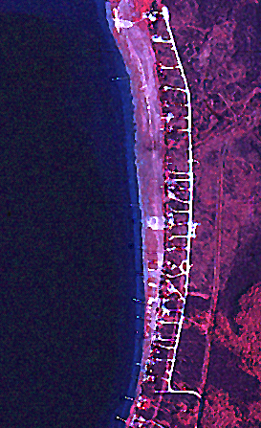
When the lake level dropped in the 1970's the zone of emergent vegetation on the north end of the lake did not advance outward to colonize the resulting shoals, nor has it during the period 1995-2003.

Property/Recreation Impacts

When the lake is low, as it is in 2003, large expanses of dry lakebed or shallow water appear in front of what was formerly lakefront property, which can be up to 700 feet from the water. Areas where users expect to be able to get their watercraft and aircraft close to their cabins dry up or become unnavigable. Silt flats and bogs appear in front of lakefront cabins along the eastern shoreline (left).

Areas in front of cabins that were open water or zones of submerged and emergent vegetation become boggy wetlands or grasslands with willow and birch thickets, and the shallows beyond are colonized by submerged and emergent aquatic vegetation (essentially becoming limited northern pike spawning and rearing habitat). Boat channels become unusable. Property owners tend to respond by excavating boat channels (both legal and illegal), setting very long docks at considerable expense, and placing structures and lawns on the dry lakebed in front of their property. Excavation of the lakebed for UAF Photo
boat channels requires government permits, resulting in a level of expense and frustration among those wishing to do a project and in occasional confrontations between government agencies and those who initiate a project without permits. When the lake rises, those who dealt with the lower level at personal expense become frustrated when their investments become superfluous, unusable, or damaged. The boat channel at the State Campground and two other public boat launching areas are becoming unusable. The State boat channel was deepened during the winter of 1999 - 2000, at considerable expense, for the third time since 1970. Little more can be done to improve it as the lake level continues to drop because the lake bottom beyond the outer end of the channel is almost level, and several hundred feet of additional channel would have to be excavated to get to deepening water.

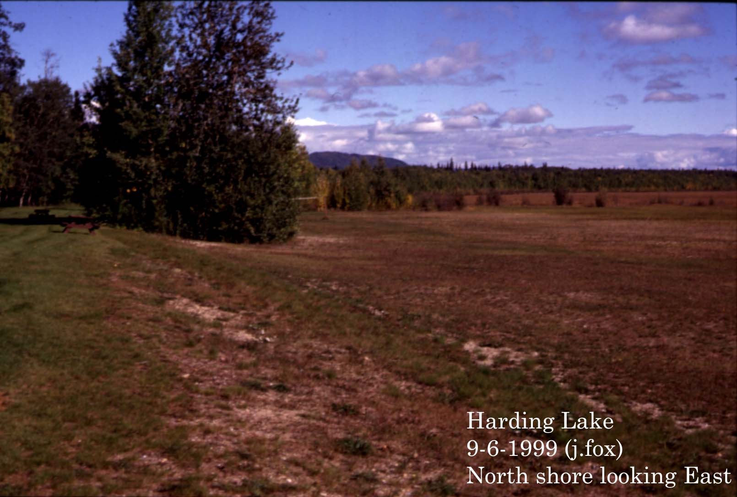
Large areas of the lake along the northern portion that were usable for boat-orientated recreation have become extremely shallow or have dried up completely, as in the photo at left (provided by John Fox) showing dry flats no longer available for swimming or canoeing, with grasslands/willow flats that were northern pike spawning areas in the distance. Larger beach zones can increase human conflicts when visitors use beaches in front of private cabins. As lake users adjust to the water level the lake changes and they must adjust again.

An association of lake users, primarily property owners, has organized to deal with issues at Harding Lake. The Harding Lake Association formed a number of committees, one of which is the Water Quality and Lake Stabilization Committee. That Committee mailed out a questionnaire to 304 lakefront and second-tier property owners, followed up by phone calls to non-respondents. Response rate was 85%. Those polled were asked whether they would like to see the lake level stabilized (or not), and if the answer was yes, to choose a preferred level within a range of options from below the present level to 6 feet above the present level. A total of 98.9% of the respondents agreed that the lake should be stabilized, and specified a preferred level (Table 1, Figure 1).

The level that received the most votes was about 3 feet above the current level at the time of the poll in 1999, which is a couple of feet below the historic high level observed since the 1930's, when cabins began to appear. Votes for higher or lower levels were even numerically on either side of 3 feet (Table 1.), but in terms of distribution were skewed toward higher levels (Figure 1.).

A three foot rise in lake level will restore a large proportion of the dried-up wetlands along the northern shoreline of the lake, and be extremely beneficial to fish and wildlife. Dry lakebed in front of private properties will be re-inundated, and areas of open water would be restored.

Table 1. Lake Level Preference Poll Results
 | Harding Lake Properties/Families
 | 1999 Lake Stabilization Poll
 | 85% Response Rate.
 | Preferred level |  | 1 lot |  |  |  |  | 1 family
 | above 1999 level |  | = 1 vote |  |  |  |  | = 1 vote
 | 0.0 |  | 2 | 0.6% |  |  |  | 1 | 0.4%
 | 1.0 |  | 22 | 6.1% |  |  |  | 10 | 3.9%
 | 1.5 |  | 6 | 1.7% |  |  |  | 6 | 2.4%
 | 2.0 |  | 74 | 20.6% |  |  |  | 53 | 20.9%
 | 2.5 |  | 32 | 8.9% |  |  |  | 20 | 7.9%
 | 3.0 |  | 91 | 25.3% |  |  |  | 69 | 27.2%
 | 3.5 |  | 11 | 3.1% |  |  |  | 9 | 3.5%
 | 4.0 |  | 59 | 16.4% |  |  |  | 40 | 15.7%
 | 4.5 |  | 4 | 1.1% |  |  |  | 3 | 1.2%
 | 5.0 |  | 55 | 15.3% |  |  |  | 39 | 15.4%
 | Total |  | 360 | 100% |  |  |  | 254 | 100%
 | 2' + |  | 91% |  |  |  |  | 92%
 | 3’+ |  | 61% |  |  |  |  | 63%
 | No, do not
 | stabilize the
 | lake level. |  | 4 | 1.1% |  |  |  | 4 | 1.6%
 |  |  | 91%-92% want a rise of 2 feet or greater.
 |  |  | 61%-63% want a rise of 3 feet or greater.
 | Preference | Number of Lots |  |  |  |  | Number of Families
 | 0 to 2.5 ft. | 136 |  |  |  |  | 90
 | 3 ft. | 91 |  |  |  |  | 69
 | 3.5 to 5 | 129 |  |  |  |  | 91

Figure 1. Lake Level preference poll results.

Hydrology/Lake Level Stabilization Options

Reports written by Kane et al (UAF/IWR, 1979) and Kinshiro Nakao (U of Hokkaido, 1980) defined the hydrology and water budget. The study and report by Kane et al, commissioned by the Alaska Department of Natural Resources, Division of Land and Water Management, is particularly instructive because it defines potential rises in lake water level driven by annual precipitation. Hydrologists recently reviewing it are essentially in agreement with its findings, and use it as the basis of their estimates of the changes in lake water level that can be achieved with different input scenarios.

Harding Lake has a contiguous drainage basin consisting of the hillsides immediately around the lake and the Little Harding Lake basin, together encompassing about 5 square miles, and excluding the 2,500 acre surface area of the lake. The contiguous basin provides water into the lake through hillside runoff, springs, permafrost seeps, and the inlet from Little Harding Lake.

UAF Photo
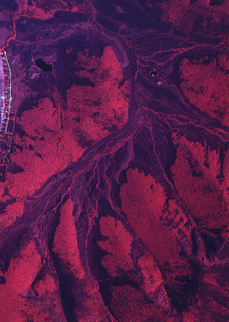
There is a second basin immediately over the hills to the east with an area of about 10 square miles (left). The stream (Rogge Creek) draining that basin comes to a divide, at which point it can flow down the North Fork into the Salcha River, or on down Rogge Creek into Harding Lake, depending on channel blockages created by beavers or other causes. There is a photograph of a breached beaver dam at the forks in 1988.

The contiguous lake basin does not ordinarily produce enough runoff to maintain the lake level. The key to maintaining an acceptable level is the runoff from the Rogge Creek drainage. The scientific studies and casual observations by locals indicate that when water from Rogge Creek is flowing into the Salcha River the lake level declines, except during periods of precipitation or snowmelt when the level will stabilize or rise due to runoff from the contiguous basin. When the full volume of Rogge Creek is flowing into the lake the level will stabilize (in very dry periods) or rise. Flow estimates of 21 and 23 cubic feet per second (cfs) have been recorded during spring runoff in Rogge Creek flowing into Harding Lake. A flow of 21 cfs was roughly estimated to be able to raise the lake 1 inch every 5 days. This is a maximum estimate of potential rise, since no evaporation, flow into adjacent wetlands, or other loss was factored in. While these were instantaneous cfs estimates and not part of a continuous recording process, they were taken when the stream channel was full and they are likely representative of peak runoff flow from an average or above average snowpack. It is not known whether the entire flow volume from the Rogge Creek basin was flowing down Rogge Creek to Harding Lake when the measurements were taken, or whether there was water also flowing down the North Fork to the Salcha River.

The lake loses water through evaporation and groundwater flow. There is no active outlet to the Salcha River that has been historically observed when water was flowing down it. However, water has been seen to flow from the lake into wetlands to the north when the lake is full. There is a clearly defined channel toward the Salcha River lowlands within these wetlands, northeast of the State Campground. The capacity of these wetlands to absorb an increasing volume of water from the lake is unknown but believed to be significant. Survey work done in 2002 indicates that water will begin to fill these wetlands and move toward the Salcha River when the lake is approximately 3 feet higher than it was in 2002 (water will begin to leave the lake at about 718.5 ASL). Parts of these northern wetlands were originally part of the lake, until they were cut off by wave/ice berms during low-water cycles. When the surface area of the lake is reduced during low water periods, new berms can form, preventing the lake from recovering to its original surface area when the lakebed refills and resulting in permanent loss of wetlands. The berms can be in excess of 3 feet in height. Such berms, perched on higher sections of lakebottom near the banks, likely dammed water into the lake in the past, resulting in some of the historically higher water levels.

A diversion structure constructed on Rogge Creek will allow the lake level to rise and be controlled within a range. A portion of the available water from the Rogge Creek basin will be directed toward the lake. In dry periods, Kane and Fox estimated that all of the runoff from the contiguous basin and the Rogge Creek basin would be needed to keep the lake at the appropriate level. In periods of "normal" precipitation a portion of the water from Rogge Creek would supplement the lake water supply to maintain the level. During periods of heavy precipitation and if the lake were at the appropriate level, all of the Rogge Creek water would be diverted to the Salcha. Harding Lake responds slowly to input from ordinary precipitation events, and in fact came up only 16 inches during the great flood of 1967. Rogge Creek was flowing into the lake at that time, but the proportion of the flow of Rogge Creek that may have gone toward the Salcha River is unknown. The amount of water that escaped the lake to the north is also unknown, but was likely substantial. Simple calculations of potential rise in level during the rainfall of August 8 – 16, 1967 indicate that there would likely have been a greater rise if water had not been flowing from the lake.

Water quality of Rogge Creek and sedimentation that might come into the lake has been raised as an issue. Rogge Creek is a typical Alaskan hillside boreal forest drainage stream. The water is usually tannic-stained, and during heavy flows into Harding Lake areas of the lake become "tea stained". This is not harmful and dissipates within a few days. Little Harding Lake, Birch Lake, Lost Lake, and many other Tanana Valley lakes have transparent brown water year-round. Coliform bacteria from animals are present in Rogge Creek, as they are in Harding Lake and other lakes wherever moose, muskrats, ducks, and other wildlife are found. Sedimentation levels can vary from the normal turbidity that occurs during spring and thunderstorm runoffs to nothing but a little bit of detritus during lower flows. The lake bottom in the area of the Rogge Creek outwash has been built by that sedimentation, and as a naturally occurring process there should be no abnormal impact when the creek is running into the lake. Siltation has been observed in the stream occasionally, probably as a result of a melting ice lens back up in the valley. When Rogge Creek is flowing into Harding Lake because of beaverdams or other natural causes, not much can be done about this. If a diversion structure were in place, water carrying an exceptionally heavy silt load could be diverted away from the lake.

Situation Summary

A project to stabilize the lake at a level higher than it was in 2003 but below the historic high water mark will benefit both fish and wildlife and the human users of Harding Lake. It will restore both northern wetlands and open-water areas along the other beachfront areas. If the water level continues to drop or remains at or near status quo (715 feet ASL), increasing acreages of vegetated wetlands will develop in front of private property. When the lake was low in the late 1970’s and early 1980’s, the importance of these areas as the only substantial spawning and rearing areas for northern pike began to be recognized.

If the lake rises sufficiently, more surface acreage would be available for recreation, and while the northern wetlands recover, the vegetated areas in front of much of the private property would be reduced by increased water depth, wave action, and ice movement. Existing boat channels and launch points would become functional. The added volume of the lake would improve water quality. The inclination of people to dig channels or modify the lakebed and shoreline in response to low water levels would be reduced, thus reducing interactions and potential conflicts with government agencies.

Project Status

The Delta Soil and Water Conservation District and HLA began to collaborate in 2000 to develop a solution to the problem of the receding waterline of Harding Lake. The two groups formed the Harding Lake Watershed Council, with members invited from stakeholder groups, particularly State and Federal Agencies involved with resource conservation and land and water management in the area. After much work by the groups involved (particularly HLA), Congress appropriated $300,000 to National Resource Conservation Service (NRCS) to design and construct the Rogge Creek structure, with restoration of northern pike spawning and rearing habitat as the objective. NRCS has done preliminary design of a sheet-pile structure. The structure will divert up to about 12 CFS down Rogge Creek into Harding Lake until the designated lake level is reached, after which flow will be restricted or shut off (directed toward the Salcha River). Construction will begin in November, 2004.

Some long-term hydrological monitoring would be needed to fine-tune the process. An agency or group must commit to maintain and operate the structure. Operation will consist of installing or removing a steel dam board that will control flow toward Harding Lake, and cleaning sediment and debris from the structure and channel in the immediate vicinity of the structure. The Sport Fish Division of the Alaska Dept. of Fish and Game has been asked to sponsor, operate, and maintain the structure.

Fish and Game Involvement

The Alaska Department of Fish & Game, Sport Fish Division, preferred to be a secondary sponsor/cooperator, simply because it is a biological research/management organization not focused on structure management, engineering, etc. However, the impetus behind the project and the objective of raising the water level is restoration of northern pike spawning habitat. ADF&G has as a management objective the restoration of the Harding Lake northern pike sport fishery (the only major roadside pike fishery in Interior Alaska), and Sport Fish Division is capable of taking on the operation of the structure. Therefore, Fish and Game will work to make the project succeed, and will commit to maintenance and operation of the structure as long as all involved recognize that ADF&G participation and efforts must result in northern pike habitat restoration.

Harding Lake Water Level and Northern Flats Dry Lakebed Survey, assessment of coverage of Northern Pike spawning and rearing areas, and recommendation for water surface elevation.

Survey done by Brett Nelson, NRCS, assisted by Lucas Henry, NRCS college intern, and Mike Doxey, ADF&G, on July 1, 2003.

The Survey
Establishment of the surface elevation of Harding Lake was done using 2 “Lidar Cap” elevation benchmarks set by the Corps of Engineers in 2002. Those benchmarks were indexed to North American Vertical Datum (NAVD) 1988, the current standard for benchmarks in this area. NAVD 1988 is about 5 feet higher than NAVD 1929, the older standard. That difference accounts for the lake elevation discrepancy between older studies, such as Kane and Fox, 1979 (which was based on survey work done by Boutet and Mendenhall in 1978), and more recent work involving surface elevations.

Surface elevation of Harding Lake on July 1, 2003 was 715.3 feet above sea level (ASL). This was about 0.3 feet (3½ inches) down from the GPS survey lake level of 2002, when Rob Gerber, the surveyor under contract to NRCS, placed markers where the waterline would be if the lake was raised in 1 foot increments. The difference is consistent with the decline of lake level between 2002 and 2003.

Transects were done from waterline on July 1 to:

1) The toe of the bank defining the break between the lakebed and uplands just north of the boat channel at the State Campground.

2) The large berm with older birch trees on it that comprises the “northeastern point” and is a reasonable natural eastern boundary of the large area of exposed lakebottom behind the northern shoals.

3) The toe of the bank defining the break between the lakebed and uplands at the dry grassland just north of Rogge Creek, which is a very important pike spawning area when sufficiently inundated.

Elevation of a private benchmark at a cabin on the western shoreline was also documented.

Northern Pike Spawning and Rearing Habitat Coverage and Recommendation
The purpose of the recommendation is to define the optimal water level to re-establish the northern wetlands of Harding Lake, the historically most productive northern pike spawning area.

The average range of recommended depths for northern pike spawning areas is 8 inches to 16 inches with an outer margin of about 28 inches (Casselman and Lewis, 1996). In Harding Lake, first-year spawning females (the smallest) are 22 – 24 inches long and have a body depth of about 4 inches. When the eggs are shed, they must be able to adhere to vegetation off of the bottom of the lake. Eight inches should be considered a minimum spawning water depth for these fish. Bigger, more productive females need deeper water.

All of the re-inundated vegetated areas will function as rearing area. Optimal depth of rearing area is dependant on size of the young fish.

To assess potential coverage of the northern flats it was assumed that the slopes of the Campground Transect and the Northern Point Transect were roughly the range of the expanse of dry lakebed between them. The slopes of the transects were averaged and horizontal linear extent of 8 inch coverage for water level increases of up to 718.3’ ASL (about 3 feet above current lake level) was calculated (Table 2). Potential coverage for the Northeast Spawning Area was similarly assessed (Table 3.)

Table 2. North Point and Campground transects averaged, Harding Lake Northern Flats
25' Interval | Avg slope 0.1125'/25' (1 5/8"/25')
Inland
Distance from Water | Average Lakebottom Elevation above Existing Water Level | Lake- bottom Surface Elevation | Add 0.67' to get 8" coverage | Lake Water Surface Elevation |  |  |  | Percent of possible spawning/rearing area inundated and 8" minimum spawning depth inshore.
Waterline (0') | 0.000 | 715.30 | 0.670 | 715.97 |  |  |  | Distance from waterline across bare
25' | 0.113 | 715.41 | 0.783 | 716.08 |  |  |  | gravel to vegetated zone varies
50' | 0.225 | 715.53 | 0.895 | 716.20
75' | 0.338 | 715.64 | 1.008 | 716.31
100' | 0.450 | 715.75 | 1.120 | 716.42
125' | 0.563 | 715.86 | 1.233 | 716.53
150' | 0.675 | 715.98 | 1.345 | 716.65
175' | 0.788 | 716.09 | 1.458 | 716.76
200' | 0.900 | 716.20 | 1.570 | 716.87
225' | 1.013 | 716.31 | 1.683 | 716.98
250' | 1.125 | 716.43 | 1.795 | 717.10
275' | 1.238 | 716.54 | 1.908 | 717.21
300' | 1.350 | 716.65 | 2.020 | 717.32 |  |  |  | 2.0' rise = 53% coverage (-47%)
325' | 1.463 | 716.76 | 2.133 | 717.43
350' | 1.575 | 716.88 | 2.245 | 717.55
375' | 1.688 | 716.99 | 2.358 | 717.66
400' | 1.800 | 717.10 | 2.470 | 717.77
425' | 1.913 | 717.21 | 2.583 | 717.88 |  |  |  | 2.5' rise = 78% coverage - (22%)
450' | 2.025 | 717.33 | 2.695 | 718.00
475' | 2.138 | 717.44 | 2.808 | 718.11
500' | 2.250 | 717.55 | 2.920 | 718.22
525' | 2.363 | 717.66 | 3.033 | 718.33 |  |  |  | 3' rise = 100% of possible spawning/rearing
550' | 2.475 | 717.78 | 3.145 | 718.45 |  |  |  | area covered and 8" minimum
575' | 2.588 | 717.89 | 3.258 | 718.56 |  |  |  | spawning depth inshore
600' | 2.700 | 718.00 | 3.370 | 718.67

A water level of 718.3’ ASL was selected as the approximate upper boundary for four reasons:

1) Water at that level (718.3’) would give reasonably complete coverage of the northern flats with water depths to the minimum 8 inches over inshore zones. Spawning area would be maximized, and as much rearing area as can be reasonably expected would be established. Targeted water levels incrementally lower than 718.3 feet would reduce the proportion of restored wetlands (Tables 2 and 3). Targeted water levels greater than 718.3 feet would be beneficial, but with diminishing returns compared to a rise to 718.3 feet.

2) In addition to lakebank and old berms that define the inshore margins of the northern wetlands, there are newer low berms at the outer margins of the vegetated area, created as the lake level dropped away from the vegetation, and there are shoals. Water should submerge these to sufficient depth to permit passage of adult northern pike and allow wave action to flush and oxygenate the deeper areas of the wetlands. At the outer ends of the Campground and North Point transects, where these features were measured, they were 5 to 18 inch high barriers.

3) The Gerber Surveys of 2002 indicated that at water levels greater than about 3 feet above existing level as of 2002 the water could begin to flow from the lake into old wetlands to the north. Inspection of aerial photographs and a site visit lend credence to this. The area where water might leave the lake is readily discernible. The shoreline berm is breached at that point. There is a clearly defined channel from the northern margin of the inland wetlands northeast of the campground over to the lowlands of the Salcha River floodplain. Taking this into account and considering that design flow from the Rogge Creek Structure to Harding Lake will be capped at about 12 CFS (about half of documented high flow down the creek into the lake), a targeted rise greater than 3 feet may be difficult to achieve.

Table 3. Transect At Northeast Pike Spawning Area, Harding Lake
50' Interval
Inland (exc,t @ 3')
Distance from Water | Lakebottom Elevation above Existing Water Level | Lake-bottom Surface Elevation | Add 0.67' to get 8" Coverage | Lake Water Surface Elevation |  | Percent of possible spawning/rearing area inundated and 8" minimum spawning depth inshore.
Waterline | 0 | 715.3 | 0.670 | 716.0
50' | 0.6 |  | 1.270
100' | 1.2 | 716.5 | 1.870 | 717.2 |  | 2.0' rise = 45% at 125' (-55%)
150' | 1.7 |  | 2.370
200' | 1.9 | 717.2 | 2.570 | 717.9 |  | 2.5' rise = 69% at 190' (-31%)
250' | 2.1 |  | 2.770
275' | 2.25 | 717.5 | 2.92 | 718.2 |  | 3' rise = 100% of possible area covered
300' | 2.4 | 717.7 | 3.070 | 718.4 |  | to 8" minimum at 285'

4) At 718.3 feet ASL the lake would be within its lakebed. At the campground beach the water level would be about 12 inches lower than the toe of the bank (at 719.3 feet, about four feet above present lake level and the lowest point on the bank, where it breaks over into lakebottom). There is photo 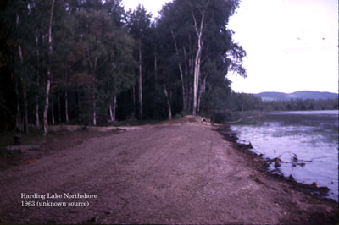documentation of water at the bank in 1963 (below) and in 1968. A water level of 718.3 feet would be about 2 feet lower than the level of 1968 (which was about 720.2 feet), about 1 foot lower than the first recovery level of 1985 (approx. 719 feet) and about 6 inches higher than the level of August, 1992 (717.8 feet). The waterline would be about 10 to 25 feet out from the bank shown in the photo. (Photo provided by John Fox).

Recommendation:

The Alaska Dept. of Fish and Game recommends that the Rogge Creek Diversion Structure be operated at a flow to maintain the water level of Harding Lake at a target surface elevation of 718.3 feet ASL, three feet above the level of July 1, 2003. This will provide adequate coverage of the Northern Flats pike spawning and rearing area with inshore areas covered to the minimum water depth of 8 inches required for northern pike spawning. When the lake level falls below 718.3 feet ASL, the structure should be operated to direct additional water down Rogge Creek into the lake. If the lake level rises above 718.3 feet ASL the flow of Rogge Creek should be diverted to the Salcha River. Response of the lake level to input from Rogge Creek will be monitored in order to tighten operating criteria over time.

In addition, the berms along the north end of the lake will be managed to ensure that excess water can flow away to the north, and that there is no further loss of northern wetlands due to berm formation. Any roads constructed across the wetlands to the north of Harding Lake must have sufficient culverts to allow the water to continue flowing northward to the Salcha River.

ADF&G strongly recommends the installation of a water level gauge/monument at the State Campground so that water levels can be monitored by the operator and all with an interest.

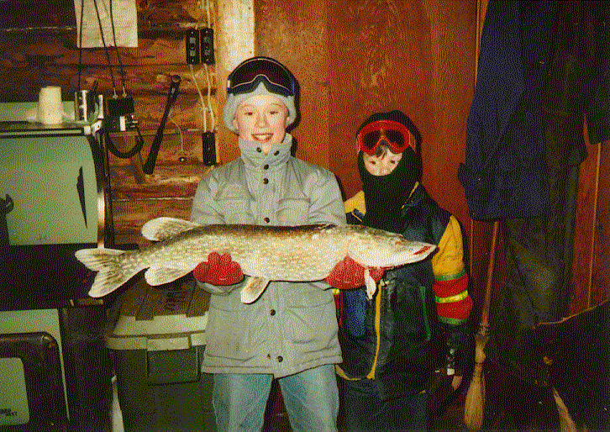

Photo by Mike Doxey

Literature Cited:

Boutet, P. Surveying NC 8. Harding Lake, Alaska Contract GSC-137, File Reference No. 2380.5. (Survey Report to Alaska Department of Natural Resources, 1978, unpub.).

Casselman, J.M. and Lewis, C.A. Habitat requirements of Northern Pike (Esox lucius). Canadian Journal of Fisheries and Aquatic Sciences 53(Suppl.1):161-174 (1996).

Doxey, M. 1991. A history of Fisheries Assessments and Stocking Programs in Harding Lake, Alaska, 1939 – 1989. Alaska Department of Fish and Game, Sport Fish Division. Fishery Manuscript 91-2. Anchorage.

Doxey, M. 2003. Fishery Management and Restoration Plan for the Harding Lake Northern Pike Sport Fishery, 2001-2004. Department of Fish and Game, Sport Fish Division. Fishery Management Report No. 03-01. Fairbanks.

Kane, D., Fox, P., Fox, J., and Carlson, R. 1979. Effect of Diverting Additional Drainage Area Runoff into Harding Lake. Institute of Water Resources, University of Alaska, Fairbanks. 28 pp.

Nakao, K. 1980. Climactic Changes in the Interior Alaska. Report of the Alaskan Paleolimnology Research Project - 1977/78/79. Faculty of Science, Hokkaido University. 77 pp.

Roach, S. M. 1998. Abundance and composition of the northern pike population in Harding Lake, 1997. Alaska Dept. of Fish and Game, Sport Fish Division. Fishery Data Series No. 98-14, Anchorage.

Scanlon, B. P. and Roach, S. M. 2000. Abundance and composition of the northern pike population in Harding Lake, 1999. Alaska Dept. of Fish and Game, Sport Fish Division. Fishery Data Series No. 00-3, Anchorage.

